FLOWCHART

**FLOWCHART**

Fig.1

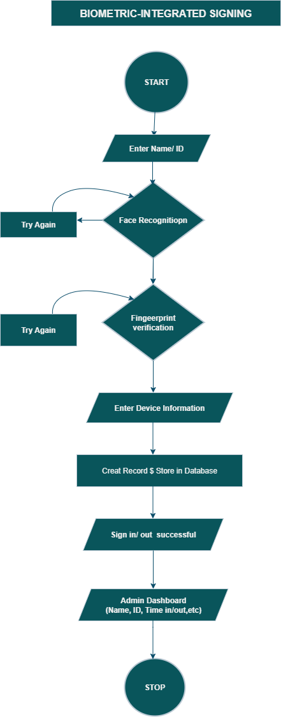

PSEUDOCODE

**PSEUDOCODE**

START

DISPLAY "Biometric-Integrated Signing System"

Step 1:

ASK student to enter Name or ID

READ student_name

Step 2:

PERFORM Face Recognition

IF face match = TRUE THEN

CONTINUE

ELSE

DISPLAY "Face not recognized, try again"

GO BACK to Step 1

ENDIF

Step 3:

PERFORM Fingerprint Verification

IF fingerprint match = TRUE THEN

CONTINUE

ELSE

DISPLAY "Fingerprint not recognized, try again"

GO BACK to Step 3

ENDIF

Step 4:

ASK student to enter Device Information (Laptop, Tablet, etc.)

READ device_info

Step 5:

CREATE record with:

- Student Name/ID

- Face recognition result

- Fingerprint result

- Device info

- Time and Date

STORE record in database

Step 6:

DISPLAY "Sign In/Out Successful"

Step 7:

ADMIN logs into dashboard

ADMIN can:

- View records (Name, ID, Time In, Time Out, Fingerprint)

- Search or edit records

END

STUDENTS SCREEN AND ADMIN DASHBOARD

**STUDENTS SCREEN AND ADMIN DASHBOARD**

**Fig.2**

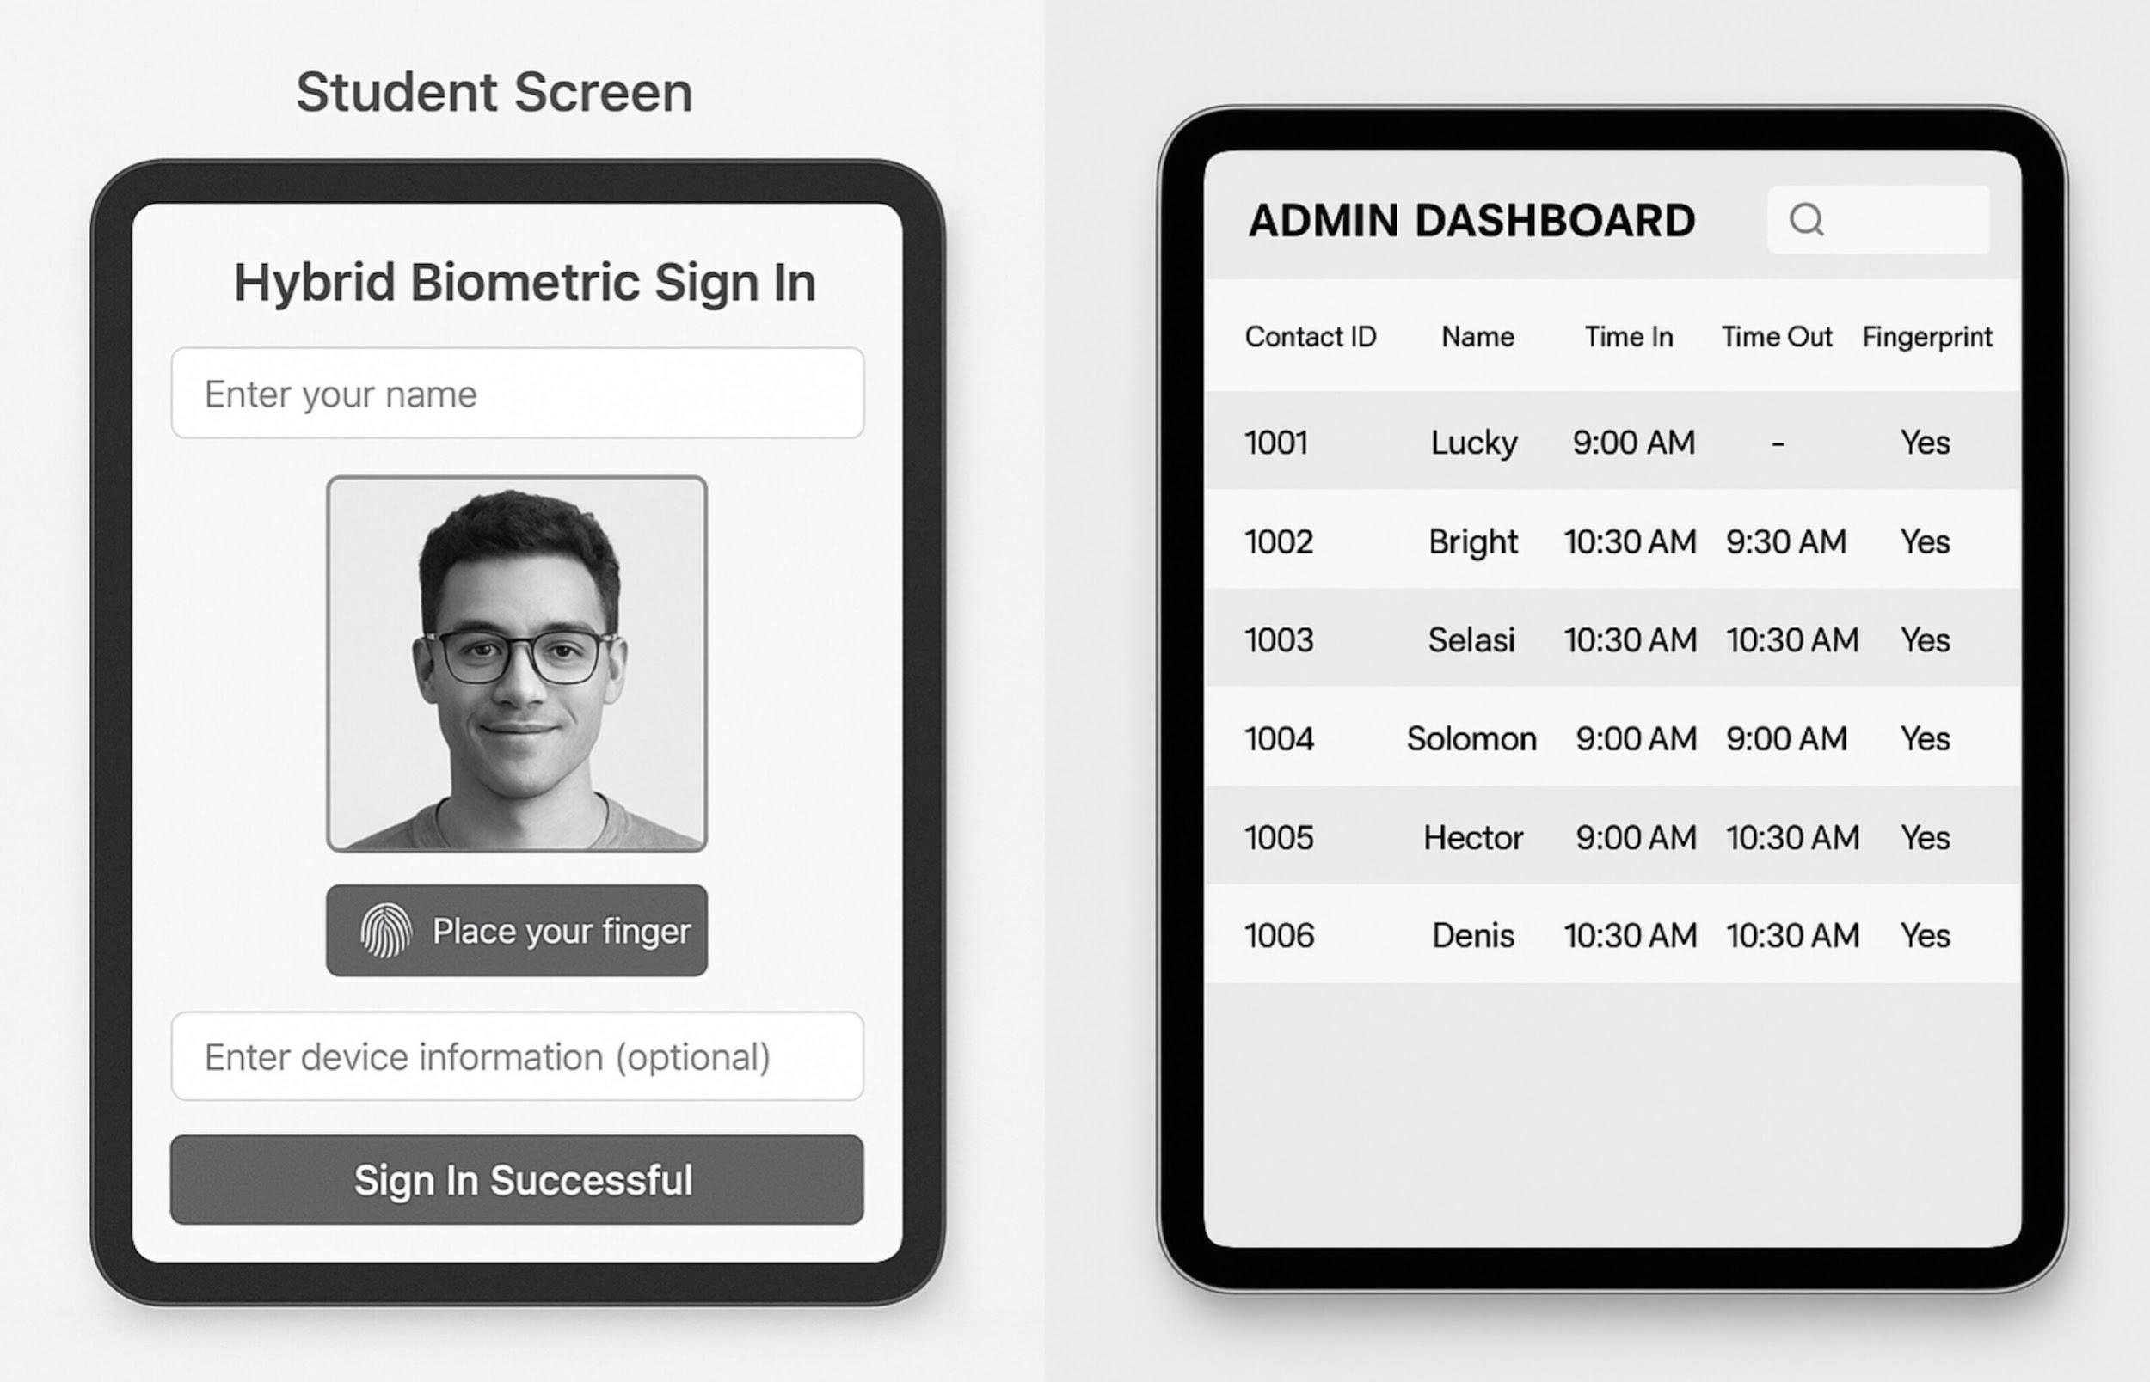

Conclusion

In conclusion, the proposed attendance System provides an efficient, reliable, and modern solution to streamline the entire process of attendance tracking within our school. By combining a robust algorithm with an intuitive and user-friendly interface, the system not only reduces errors and eliminates the delays associated with manual record-keeping but also ensures accuracy, security, and transparency in student monitoring. Furthermore, the app enhances convenience for both students and administrators, making attendance management faster, smarter, and more organized. Ultimately, this innovation contributes to improved accountability, better time management, and a more effective learning environment, positioning the school as forward-thinking and technologically driven.